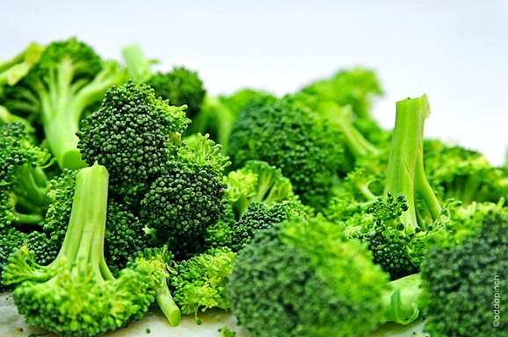 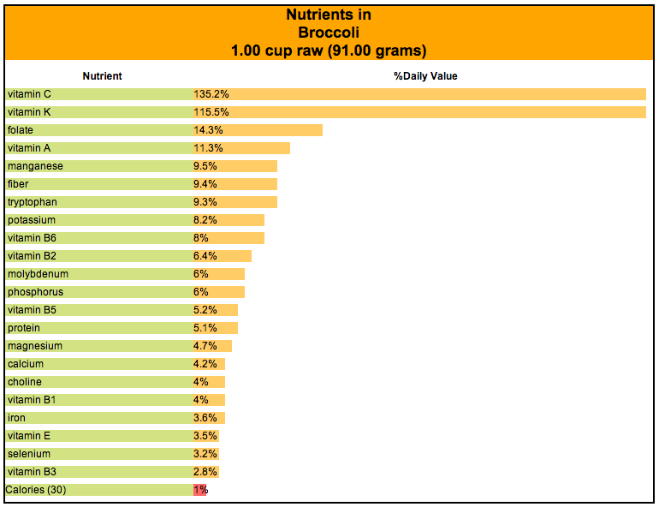

Broccoli is an amazing food!  It’s packed with photochemicals, micronutrients, and it has more benefits than most.  It lowers cholesterol, detoxifies the body, it is high in antioxidants and a rich source of flavonoids which brings about the powerful anti-inflammatory benefits of the cruciferous and cancer fighting vegetable.  Alongside of broccoli's fairly high fiber are its glucosinolates which support immune health.  Because of its high concentration of different nutrients, it also supports eye health, skin health and the metabolism of Vitamin D, which has a receptor in nearly every cell in your body.  Cook it lightly, eat it raw, just find a way to like this powerful food.

Food of the Week: Broccoli

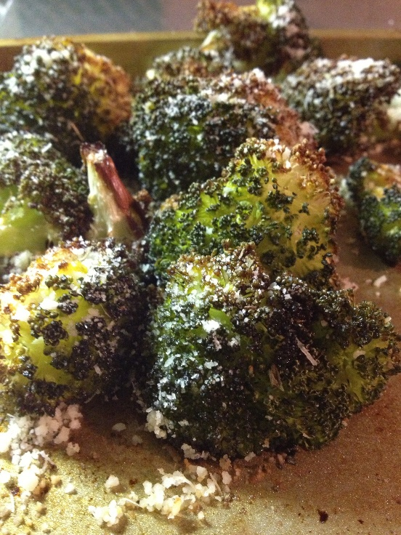

***Ingredients:***

***-Broccoli***

***-Olive oil***

***-Salt and Pepper***

***-Garlic (or garlic powder)***

***-1/3 Cup Parmesan Cheese***

***-Basil***

**Directions:**

**Preheat oven to 425 degrees F. Cut broccoli into florets. Toss broccoli with olive oil, salt, pepper, and chopped garlic. Roast in oven for 20 - 25 minutes; until the tips are browned. Remove from oven.**

**Sprinkle with lemon juice. Toss with olive oil (again), parmesan cheese, and basil.**

Garlic Parmesan Broccoli